**Class Activity**

**Group Member:**

**Muhammad Ahsan (FA18-BSE-028)**

**Rizwan Amjad (FA18-BSE-031)**

**Subject: Game Development**

**Date: 19/05/2021**

**Primary Gameplay mode of project:**

The primary game play mode of the space fighter game is single player game. In space fighter game the only one player which will fight against different objects.

**Model that are using:**

We are using iterative model in the development of space fighter game. We are developing this game in different iterations. In each iterations we will add new levels in the game.

**Screenshot of User Interface:**

Our game User interface is currently in development and very consistently working on it. But these the screenshots of some initial work.

1. **Home Screen:**

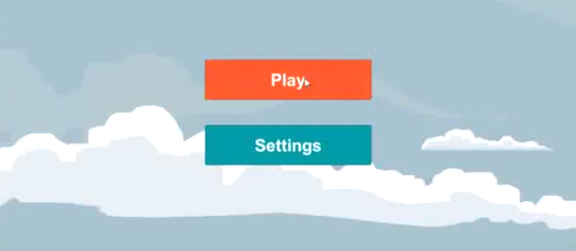

1. **Settings Screen**

